TABLE OF CONTENTS

1.Introduction 2
2.Literature Review 3
3.Problem Statement, Objectives, Scope, and Limitation 4
4.Methodology and Related Theory 5
5.System Under Consideration, Scope, and Software 6
6.Result and Analysis 8
7.Remaining Work 9
8.Conclusion 10
9.References 11

1.Introduction

Accurate and real-time prediction of transient stability is essential for ensuring the secure operation of power systems under large disturbances. The Transient Energy Function (TEF) method offers a fast and analytical way to assess stability by comparing system energy to a critical threshold (CUEP), but its effectiveness depends heavily on precise knowledge of generator rotor angles and speeds. This project proposes an LSTM-based approach to enhance the accuracy of generator state prediction during fault conditions. By training a Long Short-Term Memory (LSTM) neural network on time-series simulation data from the IEEE 9-bus system, we aim to predict generator angles and speeds in real time. These predicted states are then integrated into the TEF framework to calculate kinetic and potential energies, thereby enabling more accurate estimation of the transient stability margin (ΔV). The proposed method is expected to outperform conventional approaches by providing more reliable stability assessment and improving control action decisions such as generation shedding.

2.Literature Review
Transient stability is a critical aspect of power system operation, concerning the ability of synchronous generators to maintain synchronism after large disturbances like short circuits or line tripping. Failure to maintain synchronism can lead to cascading outages and widespread blackouts. Real-time prediction and control of transient stability are vital for ensuring grid reliability and preventing such catastrophic events. Transient Energy Function Approach is proved to be fast and accurate approach for transient stability assessment of the power system. Transient Energy Function is the mathematical model describing the energy gained by the Generator unit in the system during the fault and post fault topology. Knowledge of this energy function and the critical energy during the fault can help us to decide whether the system will stay stable or not.

3.Problem Statement, Objectives, Scope, and Limitation

- To develop and implement an LSTM (Long Short-Term Memory) neural network model for accurate, real-time prediction of generator angles and speeds in the IEEE 9-bus system following a fault

- To integrate the generator state predictions into the Transient Energy Function (TEF) framework for improved transient stability assessment

- To demonstrate the applicability of the enhanced TEF method on the IEEE 9-bus test system

4.Methodology and Related Theory
The current literature extensively covers transient stability assessment methods. Traditional approaches include time-domain simulations and direct methods like the Transient Energy Function (TEF). TEF, as highlighted in the base paper [1], provides a fast and quantitative measure of stability. However, its real-time application has been challenged by difficulties in accurately determining the Controlling Unstable Equilibrium Point (CUEP) and the sensitivity to accurate generator state (angles and speeds) measurements or predictions. The base paper specifically addresses the CUEP challenge through a combination of offline analysis (MOD) and online matching techniques (BCU method)[4].
The specific challenge of accurate time-series prediction, such as generator angles and speeds, has led to the adoption of recurrent neural network (RNN). LSTM, a specialized type of RNN, are particularly effective at capturing long-term dependencies in sequential data, making them suitable for dynamic system prediction. Several studies have applied LSTM in power systems for load forecasting [2], renewable energy generation prediction, and fault detection. However, their specific application for high-fidelity real-time generator state prediction to directly enhance TEF-based transient stability assessment, especially in addressing the accuracy of angles and speeds, represents a significant research opportunity and the core focus of this proposal.

5.System Under Consideration, Scope, and Software
Detail Proposed Methodology (with LSTM Integration)
- Data Generation and Pre-processing
  - IEEE 9-Bus System Modeling
  - Fault Simulation
  - Data Collection
  - Data Normalization

- LSTM Model Development
  - LSTM Architecture Design
  - Training Data Preparation
  - Model Training:

- Integration with Transient Energy Function (TEF)
  - Real-time Prediction Simulation (Enhanced Online Phase)
  - TEF Calculation (with LSTM-predicted States)
  - CUEP Calculation
  - Control Action Determination

6.Result and Analysis
We expect to achieve the following results from this project:
Improved Prediction Accuracy
·
Enhanced Transient Stability Assessment

Demonstration on IEEE 9-Bus System: A fully implemented and validated system demonstrating the efficacy of the LSTM-based approach for transient stability assessment and control on the IEEE 9-bus test system.

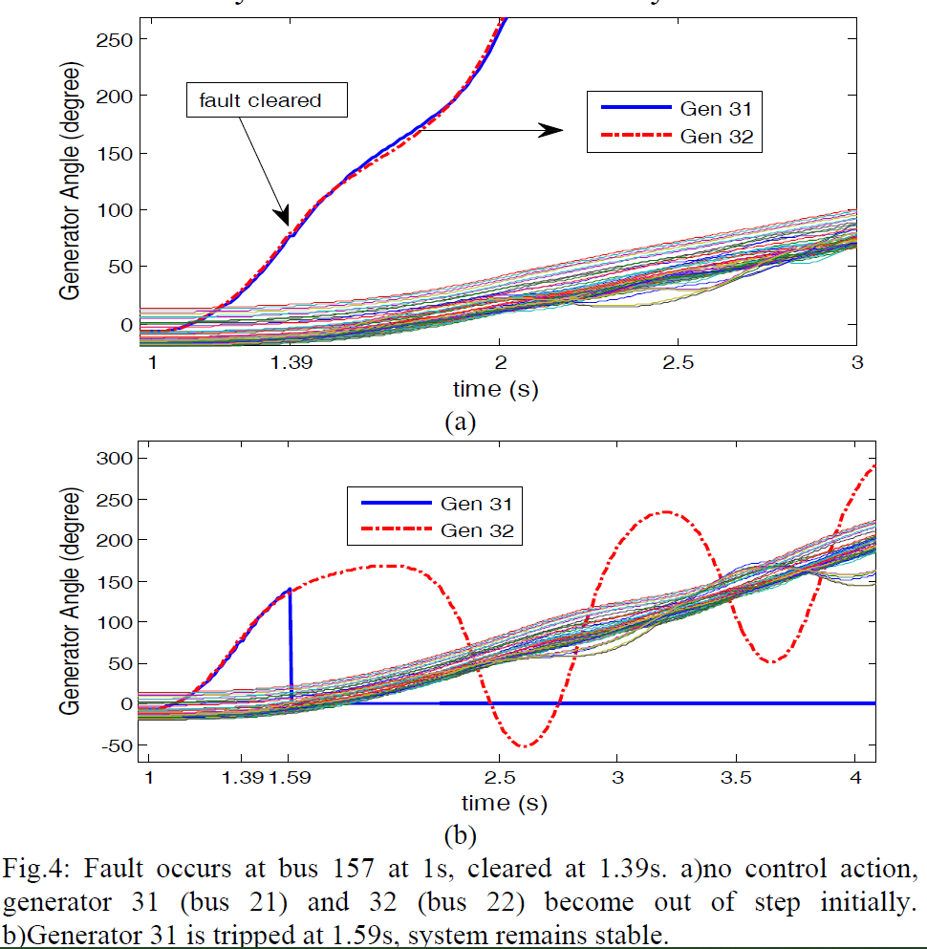

7.Remaining Work
05
MAGH
Result Analysis, Documentation, and Presentation
03
ASHOJ-KARTIK
Data Generation, LSTM Model Development and Training
04
MANGSIR-POUSH
Integration with TEF and Performance Evaluation
SHRAWAN-BHADRA
02
IEEE 9-BUS System Modeling and TEF Based Transient Stability Modeling in MatLab
ASHAR
01
Literature Review and Fundamental Learning

8.Conclusion

[1] P. Bhui and N. Senroy, "Real Time Prediction and Control of Transient Stability Using Transient Energy Function," IEEE Trans. Power Syst., doi: 10.1109/TPWRS.2016.2564444.

[2] F. Silva-Rodriguez, H. Raffoul, and Y. Li, “LSTM-Based Net Load Forecasting for Wind and Solar Power-Equipped Microgrids,” in Proceedings of the 2024 IEEE Power & Energy Society General Meeting (PESGM), Seattle, WA, USA, Jul. 2024, pp. 1–6. doi: 10.1109/PESGM56776.2024.1234567.

[3] G. Van Houdt, C. Mosquera, G. Nápoles, “A review on the long short term memory model,” Artificial Intelligence Review, vol. 53, pp. 5929 5955, 2020.

[4] H. D. Chiang, F. Wu and P. Varaiya, “A BCU method for direct analysis of power system transient stability,” IEEE Trans. Power Syst., vol. 9, pp. 1194–1208, Aug. 1994.

9.References

